Farah Diba Abrantes Braga, Ph.D. (Miss)

|  |
| --- |
| **Insper - Institute of Research (**triple accreditation - AACSB, EFMD, AMBA) https://www.insper.edu.br/en/about-insper/accreditations-and-recognition/  **Office:** Rua Quatá 300, Vila Olimpia, São Paulo, Brazil.  **E-mail:** [farahdmaab@insper.edu.br](mailto:farahdmaab@insper.edu.br) - **Phone**: +55 (11) 97544 0627  <https://scholar.google.com/citations?user=1hdzyioAAAAJ>  <https://www.linkedin.com/in/farah-diba-abrantes-braga-ph-d-mba-5b239a1/> |

PROFILE AND RESEARCH INTEREST

My research focused broadly on the transformative consumer research agenda. I have a multidisciplinary approach with the goal of bridging marketing and consumer behavior. Specifically, I investigate contextual, situational factors and psychological determinants that influences consumers’ finance decision making, social media usage, prosocial behavior, and how these behaviors impact individuals’ overall well-being. I adopt a multimethod approach using structural equation modeling (SEM), lab-experiments, surveys, and econometrics (regression on panel data). My research aims to produce insights that enrich theory as well as real-world decision-makers in the fields of consumer behavior, marketing, and public policy. I am native in Portuguese, speak English fluently, knowledge of French and Spanish.

ACADEMIC DEGREES

**Ph.D.** Marketing (Consumer Behaviour, FGV- EAESP **(**triple accreditation - AACSB, EFMD, AMBA), Brazil, 2018.

Visiting Ph.D. Cornell University, USA, 2016/2017 (a twelve-month visiting programm).

MBA Marketing, University of Bath, U.K. 2001. Advisors: David Ford; Agnes Nairn

BA Economics, Universidade Federal do Ceara, Brazil, 1993.

**PUBLICATIONS**

[Abrantes-Braga, F.D.M.A.](https://www.emerald.com/insight/search?q=Farah%20Diba%20M.A.%20Abrantes-Braga) and [Veludo-de-Oliveira, T.](https://www.emerald.com/insight/search?q=T%C3%A2nia%20Veludo-de-Oliveira) (2020), "Help me, I can’t afford it! Antecedents and consequence of risky indebtedness behaviour", [**European Journal of Marketing**](https://www.emerald.com/insight/publication/issn/0309-0566), Vol. 54 No. 9, pp. 2223-2244.

Abrantes-Braga, Farah Diba, and Tania Veludo-de-Oliveira, (2019) Development and validation of financial well-being related scales", **International Journal of Bank Marketing,** 37(4), 1025-1040.

**RESEARCH IN PROGRESS**

**R&R**: This paper investigates a new phenomenon, a change in marketing communication appeals. We find that expressing a firm’s vulnerability influences consumers’ willingness to purchase the firm’s product to help the firm survive a crisis caused by an external factor (e.g., covid pandemic). Co-Authors: Lucia Barros (FGV EAESP). Submitted to the **Journal of Advertising Research.**

ONGOING: this paper investigates how low-income consumers plan and manage their credit card spending and debt. We find that the poor are debt avert, and contrary to what the traditional economic model, they use less installments to pay for their purchasing. Co-Authors: Diogo Hildebrand (Baruch College) and Manuela Dantas (California State University). Status: manuscript under construction. To be submitted to the **Journal of Consumer Psychology**, this coming December.

ONGOING: This paper investigates whether credit cards can be a tool to diminish financial constraints and promote inclusion. We investigate patterns of consumption, installment and revolving credit usage, and payment behavior, and how these behaviors affect their financial well-being. Co-Author: Danny Claro- Insper, and Nancy Wong, Wisconsin University. Status: ongoing study – variable transformation to run models and experiments. To be submitted to the **Journal of the Academy of Marketing Science,** September 2023.

**RESEARCH GRANTS AND FELLOWSHIPS**

* FAPEPS Grant (Sao Paulo Research Support Foundation Agency) – **2022** (U$ 12,200) - project title: Credit Card as a Tool of Inclusion of the Low-Income.
* Winner of the Transformative Consumer Research – ACR Grant **2022** (U$ 1,500) - project title: Credit Card as a Tool of Inclusion of the Low-Income.
* Research Grant CAPES PDSE scholarship – Doctoral Stage 2016/1027 (US$ 6,100).
* Ph.D. Scholarship CAPES 2016-2017 (approx. US$ 13,000).
* Research Grant – CNPq/FGV-EAESP 2017 (US$ 2,000).
* Chevening Scholarship for MBAs (a United Kingdom Government Grant) 2000-2001 - (approx. US$ 33,500).

**ACADEMIC APOINTMENTS**

Assistant Professor (currently a teaching-oriented position) at Insper - I teach digital marketing, consumer behaviour, marketing analytics and marketing strategy to international undergraduates and MBA students - Aug. 2018 – current. At Insper I teach students from many nationalities such as France, Italy, German, Belgian, Singapore, Colombia, Denmark, Spain, USA, Portugal, The Netherlands, Norway, Sweden, Switzerland (https://www.insper.edu.br/en/internationalization)

*Undergraduate (Teaching Evaluation - average 3.5 of 4)*

* Digital Marketing – Insper –(80h) - 2018 - current.
* Marketing Metrics and Data Driven Marketing (Insper) (80) 2019 – current.
* Conscious Consumption and Marketing – 2022-2. - – current.
* Consumer Behavior _ 2021 -2

*MBA (Teaching Assessment - average 3.7 of 4)*

* Marketing Strategy Trends – Insper – (30h) – 2020 – current.
* Digital Marketing – Insper – 30h) – 2022 – current.

*Executive Education (Teaching Assessment - average 3.5 of 4)*

* Digital Marketing – Insper – 4h) – 2019 – current.
* Digital Marketing to CMO’s – 2022.

**Other teaching experience as invited lecturer**

*Undergraduate*

* Digital Marketing – FGV-EAESP –(40h) – 2019.

*MBA*

* Digital Marketing – FGV-EAESP –(40h) – 2019 - current

*MBA, Executive Education ,InCompany (Teaching Assessment - average 3.5 of 4)*

* Digital Connection- InCompany for AMBEV – Insper (8h) 2021-1.
* Digital Marketing – InCompany for Siemens – FGV-EAESP (8h) 2019-2.
* Digital Marketing – Executive Education and MBA Programs – FGV-EAESP –(20h)–2019- current.
* Business Intelligence and Marketing – Executive Education Program - Saint Paul 2 x (8) – 2018-2; 2019-1.
* Business Intelligence and Marketing – executive MBA - Saint Paul Business School and New York Finance Institute -1x(12h) – 2018-2.
* Business Model Generation – executive MBA - FIA (Fundação Instituto de Administração Business School) –2 (4h) – 2012-1.
* **Participation in Master of Science Thesis Committee**
  + “Response of an Incumbent to the Digital Disruption: An Exploratory Study in the Brazilian Apparel Retail”; author: Vanessa Bernardes – FGV-EAESP -2019-2
  + ‘Landownership in the Countryside of Portugal and Wildfires: A Qualitative Approach”; author: Flavia da Rocha– FGV-EAESP -2019-2.

**ACADEMIC SERVICE**

* Reviewer for the European Journal of Marketing EJM – 2021 - current
* Reviewer for AMA (American Marketing Association) Conference - 2021.
* Reviewer for ENANPAD – National Association of Research Conference – 2020 - current.
* Reviewer for journals – RAE – Business Administration Journal - 2019- current.
* Reviewer for CLAV – Latin American Conference on Retails - 2014 – current.

**CONFERENCE PRESENTATIONS AND RESEARCH SEMINARS**

* Abrantes Braga e Claro - Well-being of Low-income Consumers and Credit Card Use Conference ENANPAD 2022
* Abrantes Braga e Claro - The bright and dark side of credit card usage by low-income consumers. AMA (American Marketing Association) Summer 2021.
* Barros, Abrantes Braga, Chammas e Costa – Give a Little Help for my Business: How a ‘Vulnerability Appeal’ Fosters Consumers' Prosocial Behavior Towards For-Profit Companies – ACR (Association of Consumer Research) Conference, 2021.
* Barros, Abrantes Braga, Chammas - Give a Little Help for my Business: How a ‘Vulnerability Appeal’ Fosters Consumers' Prosocial Behavior Towards For-Profit Companies – EMA Conference, 2021.
* Barros e Abrantes Braga - Give-a-Little-Help for a Business: Consumers' Prosocial Behavior towards For-Profit Companies – Conference ENANPAD 2020
* Barros, Lucia, Abrantes Braga, Farah Diba - 'Give-a-Little-Help for a Business': Consumers' Prosocial Behavior towards For-Profit Companies - Conference EMA -2021
* Braga, F. D. M. A. A.; Isabella, G.; Mazzon, J. A. Do Digital Wallets as a Payment Method Influence Consumer in Their Buying Behavior? 2013. (Conference – ENANPAD, Brazil).
* Braga, F. D. M. A. A.; Ramos, H.; Isabella, G. Digital Payment Mode: the Brazilian Reality - Meios de Pagamento Digitais: a realidade brasileira. Um estudo de Segmentação Ambiental. 2013. (Conference – SEMEAD, Brazil).
* Do Digital Wallets as a Payment Method Influence Consumer in Their Buying Behavior? 2013. ENANPAD – Conference on Post Graduation Administration Scientific Research, Brazil. <http://www.anpad.org.br/~anpad/eventos.php?cod_evento=1>
* Digital Payment Mode: the Brazilian Reality - Meios de Pagamento Digitais: a Realidade Brasileira: um estudo de Segmentação Ambiental. 2013. SEMEAD – University of Sao Paulo Conference on Administration. Brazil.
* Latim America Conference on Retail - CONGRESSO DE VAREJO DA AMÉRICA LATINA – CLAV – Paper reviewer 2014, 2015 and 2016.
* An investigation into behaviour and customer lifetime value of members of the **Wildowl & Wetlands Trusts** in order to consider the implications of a shift from a 'benefit led to a cause led' approach to membership marketing. **2001 – MBA dissertation, Bath.**

#### INDUSTRY EXPERIENCE

* 2011 - 2012 – Business Development and Marketing Director – Neuralnet, Credit Card Company.
* 2009 – 2010 - Foreign Trade Operations Manager – Quattor/Brasken Petrochemical.
* 2005 – 2009 - International Business Development – Sab Trading Company.
* 2004 – 2005 - International Business Development and Marketing, Emigran Ornamental Stones.
* 2002 - 2004 – Business Development and Marketing, Alana Group, Credit Card Company.
* 1996 – 2000 – International Business Development – Federation of Industries.
* 1992 – 1996 – International Business Development – Granos - Ornamental Stones Industry.

**SELECTED COURSE WORK (Ph.D.)**

**Marketing**

* Behavioral and Decision-Making Research (Jay Russo, at Cornell University, 2016).
* Consumer Behaviour.
* Advanced Consumer Behaviour (Nancy Wong, University of Wisconsing, 2020).
* Marketing Theory.
* Pro-Seminars in Marketing

**Methods**

* Measurement and Structural Equation Modeling (SPSS and R)
* Experimental design and analysis for behavioral research.
* Mediation, Moderation and Conditional Process Analysis.
* Multivariate Analysis (Quantitative Methods).
* Qualitative Consumer Behaviour Research (Daiana Haytko - East Carolina University)
* Qualitative Methods in Research

**ACADEMIC REFERENCES** (business related references upon request)

* Tania Veludo-de-Oliveira (Committee Chair), Professor, Marketing, FGV – EAESP (BR). E-mail: [tania.veludo@fgv.br](mailto:tania.veludo@fgv.br); phone: +55 (11) 96284 7987.
* Agnes Nair – Professor and Chair of Marketing, School of Economics, Fianance and Management at University of Bristol - agnes.nairn@bristol.ac.uk
* Diogo Hildebrand – Assistant professor of marketing at Zicklin School of Business – Baruch College – NYC - Diogo.Hildebrand@baruch.cuny.edu

Farah Diba Abrantes-Braga

**STUDENTS’s REVIEWS (https://www.linkedin.com/in/farah-diba-abrantes-braga-ph-d-mba-5b239a1/details/recommendations/?detailScreenTabIndex=0)**

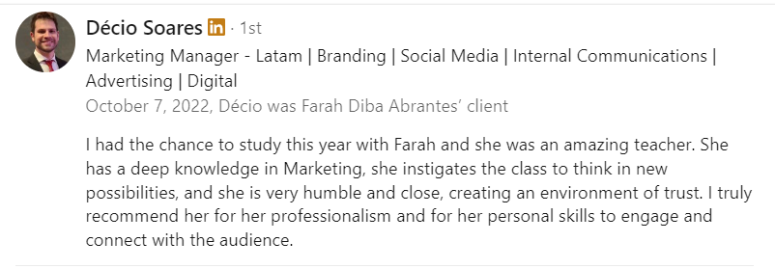

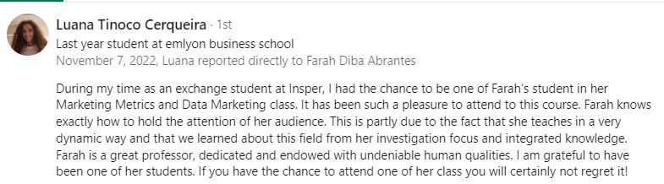

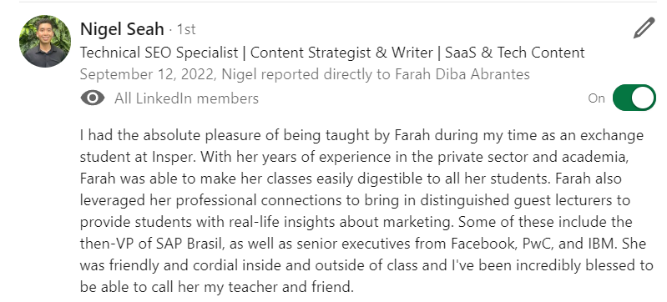

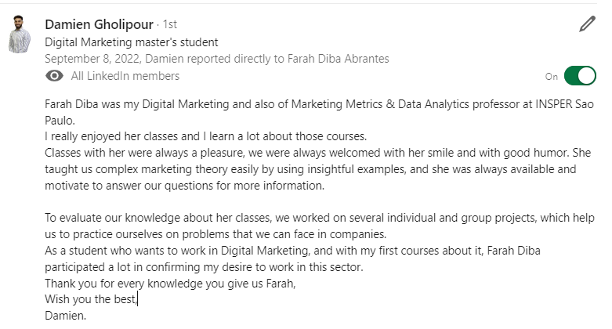

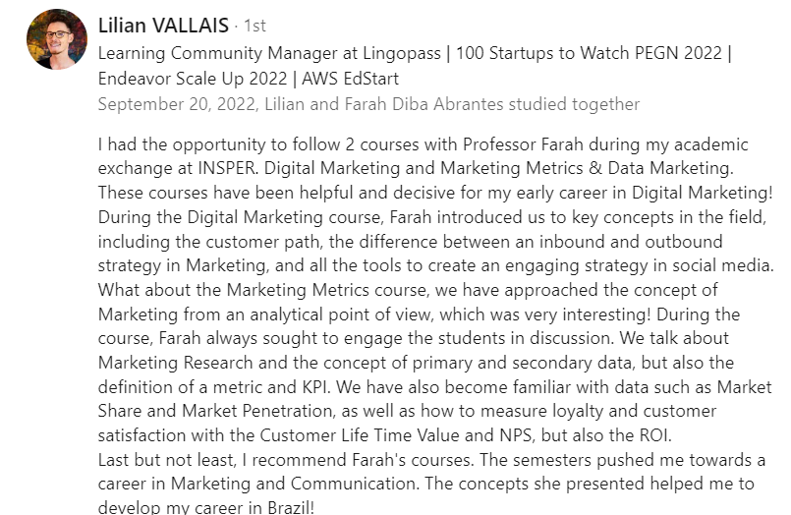

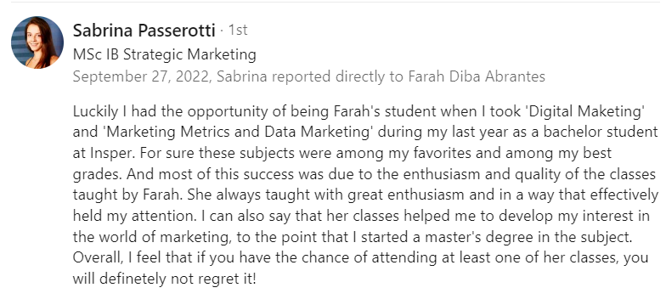

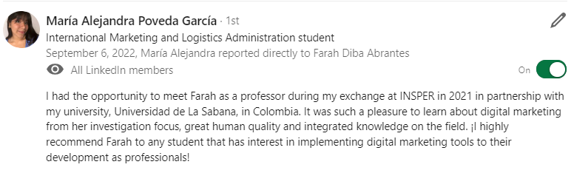

**Research and Teaching Statement - Farah Diba Abrantes-Braga – 2022**

**Research Focus**

My research focused broadly on the transformative consumer research agenda. Several initiatives around the world have called for a multidisciplinary approach that promotes research and practical solutions aiming to empower consumers to make better financial decisions and that encourages scholars and companies to build a ‘marketing for a better world.’ In line with this approach, my research has a multidisciplinary approach with the ultimate go of bridging marketing and consumer behavior (e.g., marketing strategy, consumer financial decision making, prosocial behavior). Specifically, I investigate contextual, situational factors and psychological determinants that influences consumers’ decision making toward finance and prosocial behavior, and how these behaviors impact individuals’ overall well-being. I adopt a multimethod approach using structural equation modeling (SEM), lab-experiments, surveys (conducted by myself), and panel data (modeled by my co-authors and myself). My research aims to produce insights that enrich theory as well as real-world decision-makers in the fields of consumer behavior, marketing and public policy.

**Published Research**

My published research (two papers outcome of my doctoral dissertation) contributes to literature first by offering a clear conceptualization of constructs related to financial well-being (i.e., financial preparedness for emergencies, risky indebtedness behavior, and credit limits misconceptions). Second, by testing these measures in a model that investigates the interplay between such constructs, it adds to the existing literature by examining the main psychological traits, attitudinal beliefs, and behavioral spending practices that could preclude an individual consumer from preparing for a financial emergency. It also contributes new knowledge to the literature by critically reexamining the indebtedness phenomenon. The two papers are published in the International Journal of Bank and Marketing (2018) and the European Journal of Marketing (2020).

**Research Pipeline**

I have currently one R&R and two ongoing investigations in my pipeline.

**R&R**: This paper investigates a new phenomenon, a change in marketing communication appeals. We find that expressing a firm’s vulnerability influences consumers’ willingness to purchase the firm’s product to help the firm survive a crisis caused by an external factor (e.g., covid pandemic). Co-Authors: Lucia Barros (FGV EAESP). Submitted to the **Journal of Advertising Research.**

ONGOING: this paper investigates how low-income consumers plan and manage their credit card spending and debt. We find that the poor are debt avert, and contrary to what the traditional economic model, they use less installments to pay for their purchasing. Co-Authors: Diogo Hildebrand (Baruch College) and Manuela Dantas (California State University). Status: manuscript under construction. To be submitted to the **Journal of Consumer Psychology**, this coming December.

ONGOING: This paper investigates whether credit cards can be a tool to diminish financial constraints and promote inclusion. We investigate patterns of consumption, installment and revolving credit usage, and payment behavior, and how these behaviors affect their financial well-being. Co-Author: Danny Claro- Insper, and Nancy Wong, Wisconsin University. Status: ongoing study – variable transformation to run models and experiments. To be submitted to the **Journal of the Academy of Marketing Science,** September 2023.

**Future research interests**: investigate the harmful effects of social media social media and fake news in digital marketing. In **summary**, when it comes to research, my primary interests are in behavioral experiments and actual behavior analyses applied to the field of consumer behavior and marketing. I have pursued these interests to date by researching in an emerging economy context. In the immediate future, I would like to go further and investigate different contexts employing lab, lab-in-the-field experiments, and the analysis of datasets. In the long term, I see myself as a proficient teacher and research on marketing, transformative consumer behavior, prosocial behavior.

**Teaching**

Early in my academic career, I became a keen observer of my professors, both at FGV and at Cornell University, comparing their different philosophies and approaches, teaching methods, and assessing which methods enhanced my learning. When I ended my Ph.D. and started at Insper, I was (I am) provided of professional and comprehensive training on teaching, where I learn different methods applied all over the world, both traditional, online (synchronous and asynchronous) classes and distance learning. I have learned methodologies employed in Harvard, Cornell, the University of Bath and the top business schools in Latin America. Insper’s training focuses on a student-professor centered learning, on how to plan courses, how to develop and conduct business cases, how ro profide feedback, to say a few examples.

Combined, my previous experience as an executive in the marketing field, team leader, and my current academic training and experience, I deliberately amassed a compilation of effective teaching techniques (e.g., case studies, simulation, gamification). The refinement of those years of observation, training, and experience, combined with the lessons that I am still learning from my own teaching experience, produces the dominant principle that I strive for in the classroom: objectivity, dynamic learning, and clarity (in presenting material, in detailing expectations, and in expressing educational goals).

My courses are well planned, and in advance, nonetheless, I am flexible regarding the direction of the course. Since most of my classes are half lecture and half discussion-based, it relies on issues and interests also identified by the students, and I make it clear to them that it is, in part, their responsibility to direct the course. I continually challenge students to enhance their thoughts on a variety of topics and encourage them to generate their own clear opinions about the issues dealt with in the course. In this way, I attempt to not only model clear thinking but expect it from the students.

In summary, the training that I have been receiving since the beginning of my academic life (Ph.D. started in 2014), along with my careful observations of the teaching styles, methods, and philosophies that I experienced throughout my education, provide a significant compilation of effective teaching techniques from which I draw. The embodiment of those varied approaches leads me to adhere to a principle of clarity, which demands that my lectures, expectations of students, and educational goals for them be as transparent as possible in the interest of maximizing their educations.

mas